Amazon AWS Services
Clicking “Nodes” icon at the left sidebar, the resource panel switches to Amazon AWS services’ resource. Consistent with AWS console, AWS services are categorized into:
- Compute
- Storage
- Networking
- Database
- Groups
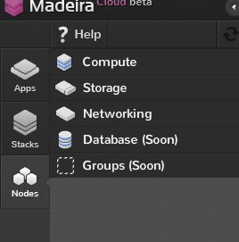
You can proceed to the following chapters by selecting one of these categories.

- Compute
  - EC2 Instances
Here you can find all EC2 instances under your AWS account. Double-click the instance icon shows more details:
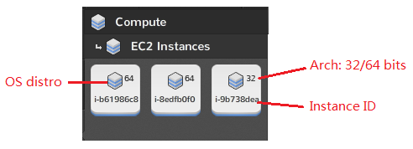
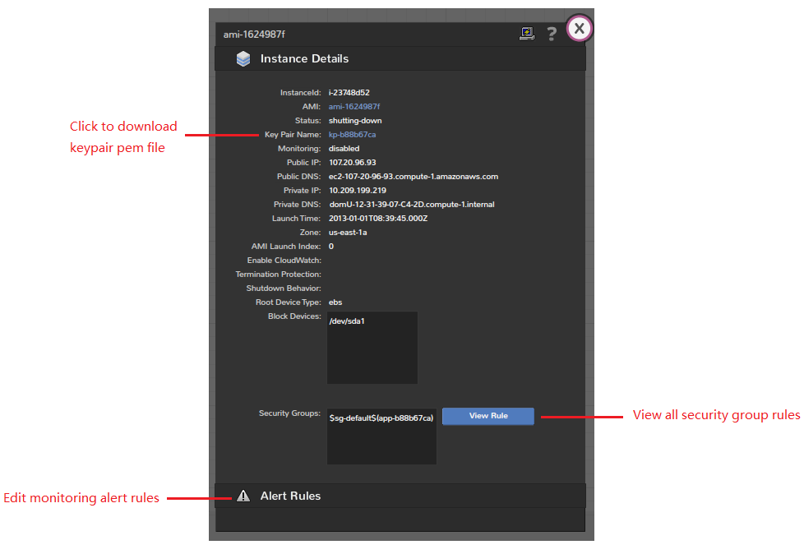

  - EC2 AMIs
This sector shows all AMIs you can use to design the stack and provision apps. Again, AMIs are categorized into three groups:
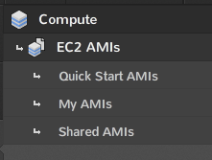
- Quick Start AMIs:
all AWS quickstart AMIs, plus AMIs prebuilt by us (Note, the quickstart AMIs vary across regions).
- My AMIs:
private AMIs generated by yourself.
- Shared AMIs:
display all public available AMIs offered by community, and you can edit your favorites!

An AMI icon shows basic information：
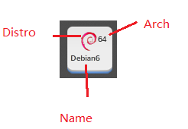
Double-clicking an AMI icon will reveal more details of the AMI.
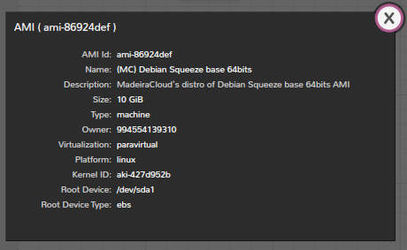

In the “Shared AMIs” sector, clicking “Browse Shared AMIs” button, a dialog pops up, where you can view and add others’ AMIs to your favorites (and remove from your collection).
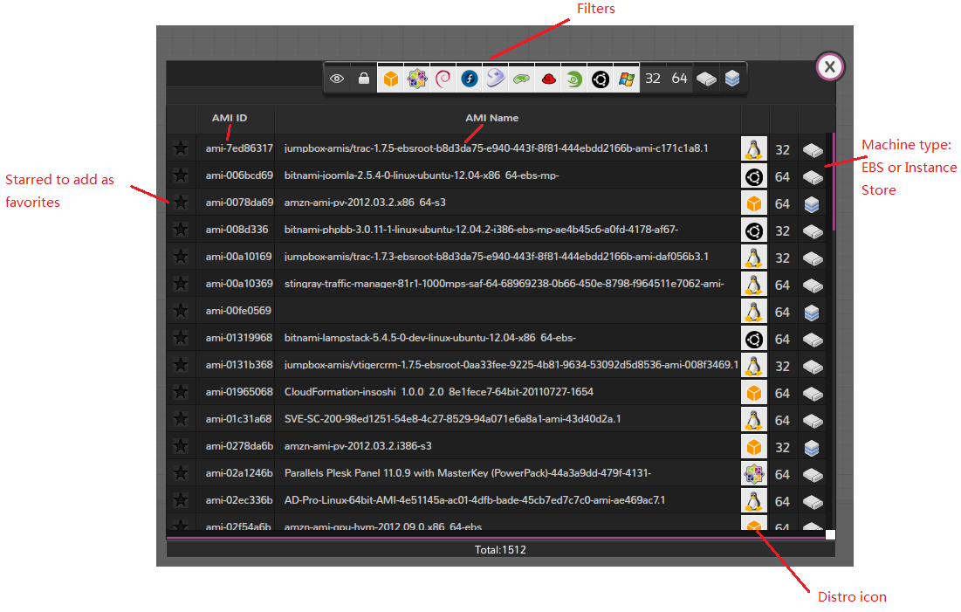
Filters are:
- Public AMIs shared to anyone
- Someone’s AMIs shared explicitly to you
- (and others) OS/Distros
- Architecture, 32bits or 64bits
- EBS based AMIs
- Instance-store based AMIs

Drag-n-drop an AMI icon to the editor, you can double-click it and setup the instance configuration：
- Instance Details

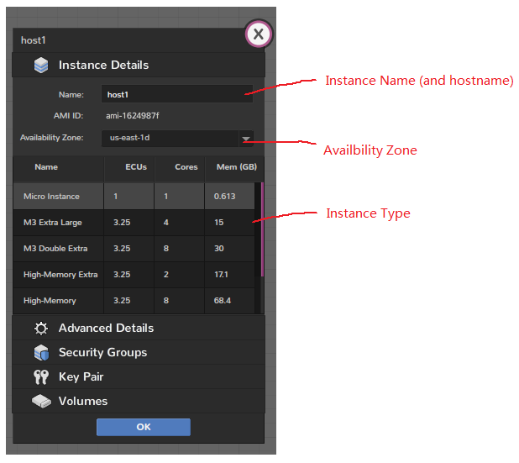

- Advance Details
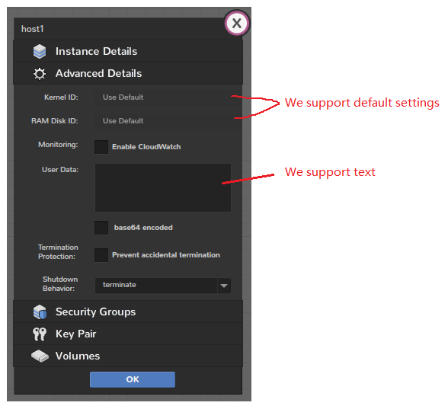
- Security Groups
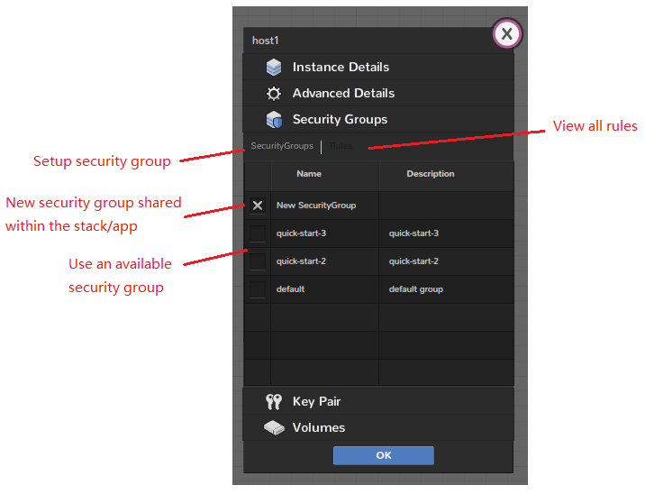

- Key Pair
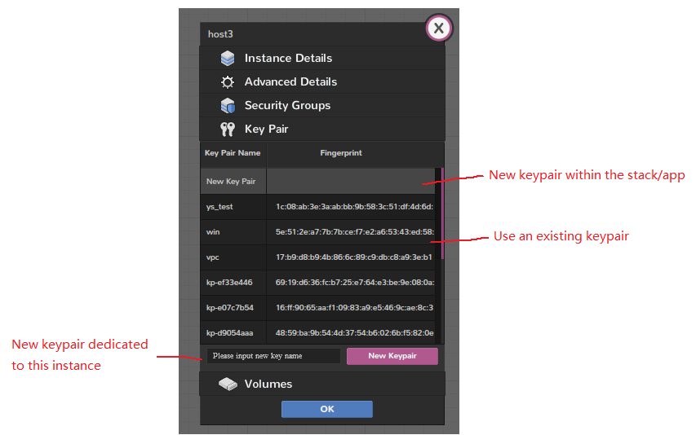
- Volumes
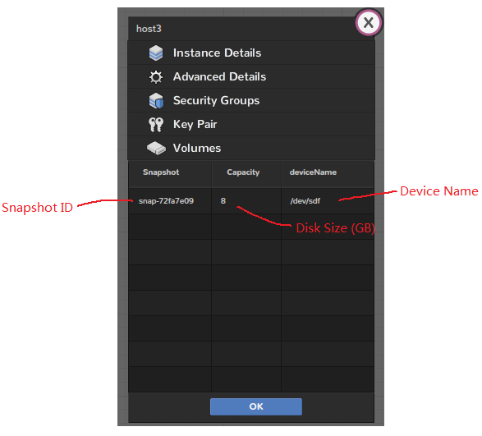

- Storage
2.1 EBS Volumes and Snapshots
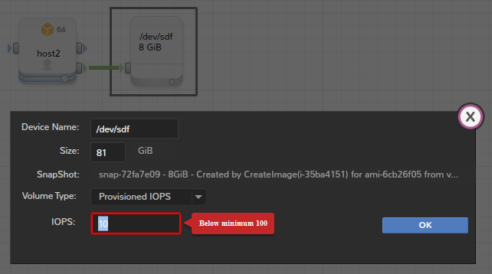

- Networking
3.1 ELB
- Configure load balancing policy:
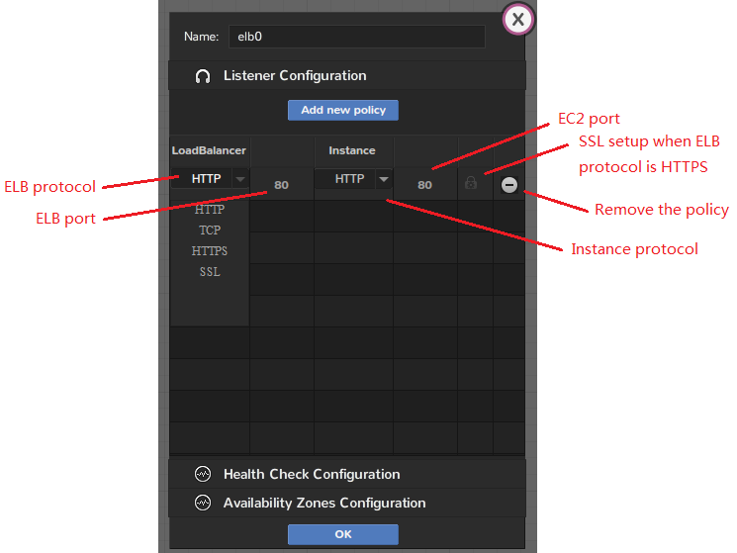

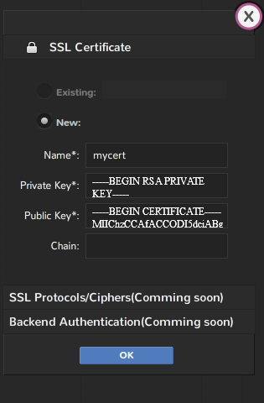

- Configure ELB health check
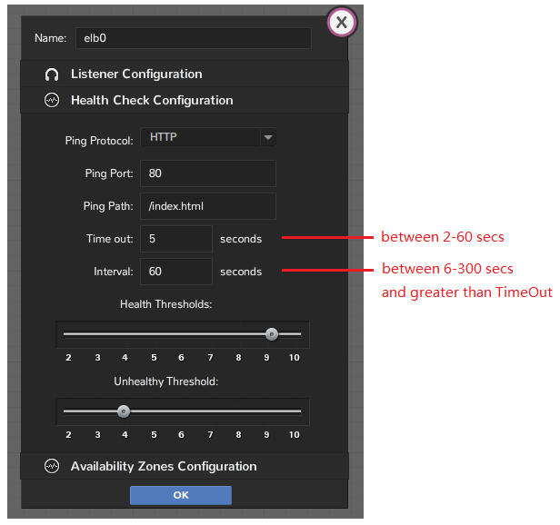

- Configure Availability Zone
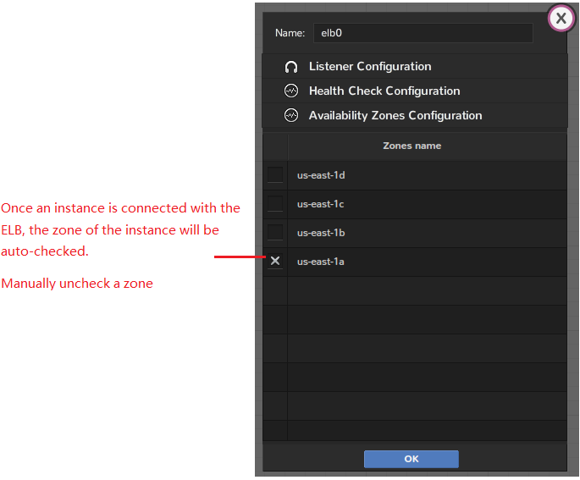

3.2 Elastic IPs
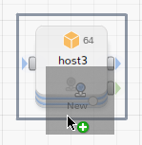
Drag-n-drop the “New” EIP icon to an AMI. Upon provisioning, a new elastic IP will be allocated and attached to the new instance. The IP will be detached from the instance and released along with the app termination.
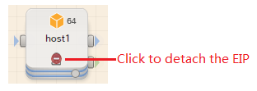

- Database (Coming Soon)
- Groups
5.1 Availability Zone
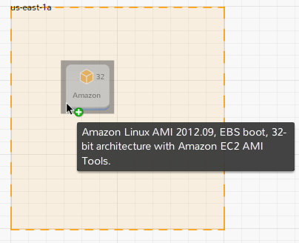
When using Availability Zone in IDE, there are some rules:
- New stack starts with the first azone in the corresponding region;
- AMI, EBS Volume/Snapshot must be placed in an azone;
- EBS volume/snapshot must be placed in the same azone with the instance they attach to
- To move an instance attached with volume/snapshot (vice versa), you need to detach them first

